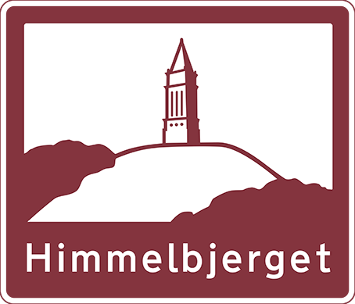
- Himmelbjerget grants are available for children ages 10 to 18, and are for full or partial registration cost for Himmelbjerget Danish Camp in Corbett, Oregon.
- Submission deadline is April 13th, 2018
- Mail, or email, this application form and a 100-word typed essay on "Why I want to go to Himmelbjerget Danish Camp" (Parents: Helping with typing is fine, but please allow your children to use their own words)

Mail to: Email to:
Mt. Hood Lodge# 81 Lodge81DSS@gmail.com
16116 SW Deline Ct.
Beaverton, OR 97007
Name of Camper:__________________________________________ Birth date:_________________

Address:____________________________________________________________________________
City:__________________________________________ State:___________ Zip:__________________
Phone#:____________________________ Email:___________________________________________
Name and Relationship to Sisterhood Member (if applicable):
____________________________________________________________Lodge#__________________
How did you hear about Himmelbjerget Danish Camp________________________________________ Have you attended Himmelbjerget Danish Camp before? Yes No
If yes, how many years _________
Are you applying for any other grants from other organizations towards Himmelbjerget Danish Camp this year? Yes No
If yes, please list organizations____________________________________________________________
I am the parent/guardian of the minor child who is applying for a Himmelbjerget Camp Grant, and agree that Danish Sisterhood of America will not be held responsible for any accidents or other occurrences to or from the camp, or while in attendance if a grant is awarded.
Submission deadline is:
April 13th , 2018
___________________________________________________
Parent/Guardian's Signature Date

